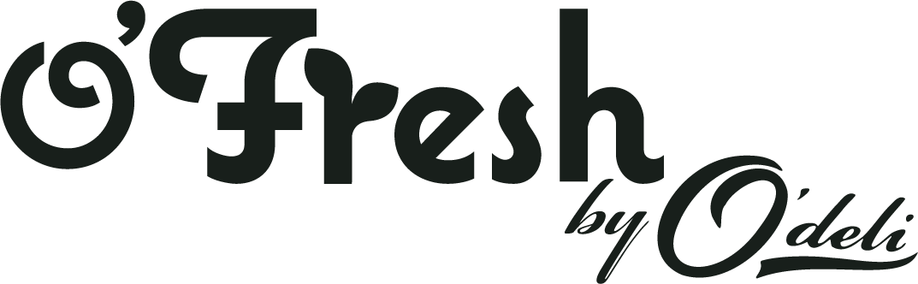

Thank you for ordering with us
Please complete this form and email it back to us at sales@odelibar.co.uk. If ordered before 3pm, we will aim to get it to you within 24 hours. Please include all required information even if you have ordered with us previously.
Required order information

NAME

DELIVERY ADDRESS
CONTACT NUMBER CONTACT EMAIL

Payment methods

You can pay cash or card on arrival of your delivery. Alternatively, you can pay by bank transfer.
I would like to pay by:
☐ CASH ☐ CARD ☐ BANK TRANSFER

ORDER DETAILS

Please fill in here the items you require, and quantities or weights of those items (preferably kg). Our full list of current products is available to view on the PRODUCT LIST page on our website.
PLEASE NOTE: We will not know the price of your order until it has been put together to go out for delivery. If any items are unavailable on the day of delivery, you will not be charged.
ITEM | QUANTITY | ITEM | QUANTITY
Delivery times

Unfortunately, due to the sheer amount of orders, we cannot designate/predict delivery times. Delivery is FREE.
Like Nana Did, Bondgate Bakery & Middlemiss orders

We are working with Like Nana Did, Bondgate Bakery and Middlemiss Butchers. If you want any of their products included in your fruit and veg delivery, please order and pay with them separately- we can then arrange for them to be delivered together.
Like Nana Did - email: likenanadid@gmail.com (Order and pay with them separately)
Middlemiss Butchers - tel: 01943 462611 (Order and pay with them separately)
Bondgate Bakery - tel: 01943 467516 (Order through O'Fresh, bread options available to view in the product list)

